

UNIVERSITY OF NAIROBI

SCHOOL OF COMPUTING AND INFORMATICS

###### MEDICAL IMAGE ANALYSIS FOR BRAIN AND BREAST CANCER DETECTION

BY:

###### CHIRCHIR EMMANUEL KIBET

###### THIS PROJECT REPORT IS SUBMITTED IN PARTIAL FULFILLMENT OF THE REQUIREMENTS FOR THE DEGREE OF BACHELOR OF SCIENCE IN COMPUTER SCIENCE OF THE UNIVERSITY OF NAIROBI.

JUNE 2024

### DECLARATION

###### I hereby declare that the project documentation report entitled “Medical Image Analysis for Brain and Breast Cancer Detection” written and submitted to University of Nairobi, School of Computing in outcome of my own efforts, it contains no material which has been accepted for the award of any other degree in this or other University. I hereby certify that the work presented in this report is my own and that work performed by others is appropriately cited.

Name: .

Registration Number: P15/140389/2020 .

###### Signature: Date:

This report has been submitted in partial fulfillment of the requirements of the Degree of Bachelor of Science in Computer Science of the University of Nairobi with approval as University Supervisor.

###### Signature: Date:

Supervisor: Prof. Elisha Opiyo

Department of Computing and Informatics

### DEDICATION

The present project is devoted to all people as well as their close ones who must face such severe diseases as brain and breast cancer

To the dedicated healthcare professionals and researchers, who are striving to enhance the methods of cancer diagnostics and treatment, your efforts and devotion are the core of the constant development of medical technologies. People’s lives are changed by your efficient work bringing hope and light to so many.

Finally, it goes to my family and friends as they have always been my strength and driving force during this strict and long process. It is very much symbolic of your faith in me and for my dedication to effect positive change out there in the sub specialization of medical imaging and especially in cancer detection.

### ACKNOWLEDGMENT

I would like to extend my sincerest gratitude to all those who supported and helped in the realization of this project. First, I would like to express my gratitude to my project supervisor Professor Opiyo, for the help in the course of work and a great deal of advice. I should also thank other subjects of the study who shared their ideas, agreed to participate in the conversations and offered encouragement that help to handle the difficulties of the work done for the project. I also want to thank the online development and research communities especially those in Kaggle for sharing their knowledge, and especially datasets which were very useful in training our machine learning algorithms. Finally, I would like to thank my family and friends who encouraged and supported me throughout time, had faith in me, and encouraged me to finish this great work. This project is not only an accomplishment of myself but to all the people who supported me throughout this project.

### ABSTRACT

In cancer diagnosis, the identification and segmentation of brain and breast cancers are specific and time-sensitive functions that explicitly influence treatment and patient prognosis. Current conventional imaging techniques rely on considerable ability of tumor recognition and margin definition by the radiologist along with concurrent input provided by the oncologist, which is a time-consuming procedure vulnerable to errors, thus his may cause diagnostic delay and imprecision. This project intends to design a novel medical image analysis application based on Machine Learning (ML) and Artificial Intelligence (AI) to handle such issues. The application utilizes artificial trends to automatically extract tumor regions in the brain and breast MRI, based on novel machine-based learning algorithms which are trained with large datasets from Kaggle. It offers a user-friendly graphical user interface through which image data can easily be managed correlated, analyzed and the generation of standard and specific radiological reports is enhanced. Using the application, the process of tumor contouring, which is typically a time-consuming and labor-intensive task executed by oncologists, is automated, which raises the diagnostic efficacy and accelerates the of treatment planning, thereby improving the patients’ health outcomes for cancer patients.

Contents

Acknowledgement 4

Abstract 5

List of Figures 8

CHAPTER 1: INTRODUCTION 10

1.1 Background 10

1.2 Problem Statement 10

1.3 Goal and Objectives 11

1.4 Significance of The Study 12

1.5 Scope of the Project 13

CHAPTER 2: LITERATURE REVIEW 14

2.1 Introduction 14

2.2 Manual Diagnostics of Cancer 14

2.3 Artificial Intelligence in Healthcare 14

2.4 Machine Learning in Cancer Diagnosis 16

2.5 Convolutional Neural Networks in Cancer Diagnosis 16

2.6 Machine Learning & CNNs in Cancer Diagnosis 17

2.7 Related Works 17

2.8 Existing Medical Image Analysis Systems 19

2.9 System Gaps 21

2.10.0 PROPOSED SYSTEM: Medical Image Analysis Application for Cancer Detection 22

CHAPTER THREE: METHODOLOGY 23

3.1 System Development Methodology 23

CHAPTER FOUR: SYSTEM ANALYSIS AND DESIGN 25

4.1 Overview 25

4.2 System Analysis 25

4.2.1 Feasibility Study 25

4.2.2 Requirements Analysis 26

4.2.3 Requirements Specification 29

Functional Requirements 29

Non-Functional Requirements 29

4.3 System Design 30

4.3.1 Architectural Design 30

Architecture Overview 31

Components Description 31

4.3.2 Process Design 32

4.3.3 User Interface 35

4.3.4 Database Design 45

CHAPTER FIVE: SYSTEM IMPLEMENTATION 46

5.1 Chapter Overview 46

5.2 . Hardware and Software Requirements 46

5.2.1. Hardware Requirements. 46

5.2.2. Software Requirements. 46

5.3 . Implementation Results 47

5.3.1 Model Development and Training 47

5.3.2 Application Development 54

5.4 System Testing 56

5.4.1. Unit Testing. 56

5.4.2 Test Cases 57

CHAPTER SIX: CONCLUSION AND RECOMMENDATIONS 58

6.1 Chapter Overview 58

6.2 Achievements 58

6.3 Conclusions 58

6.3 Recommendations for Further Work 59

REFERENCES. 60

1. Logging In 61

2. Home Page Navigation 62

3. Managing Patient Reports 64

4.Analysis of Diagnosis 68

5. Conducting Diagnoses 69

6. Viewing and Saving Diagnostic Results 71

## List of Figures

Figure 1Proposed System Architecture 22

Figure 2 Methodology 23

Figure 3Evidence of Interview of cancer state and discussion 28

Figure 4 System Architecture 30

Figure5HighLevelDesign 33

Figure 6 Medical Image Processing Workflow 34

Figure 7 Flowchart 35

Figure 8 Login Page 36

Figure 9 Registration Page 36

Figure 10User Profile Page 37

Figure 11 Home Page 38

Figure 12 Patient Information Page 38

Figure 13 Patient Details Page 39

Figure 14 Diagnostics Page 40

Figure 15 Visualization Page 41

Figure 16 Use Case 44

Figure17Database#Design 45

Figure 18 Metrics for the brain and breast scan classifier model 47

Figure 19 Results of the Brain and Breast scan classifier model 48

Figure 20 Training metrics for Brain Tumor Classifier model 49

Figure 21 Results of the Brain tumor classifier model 49

Figure 22 Metrics for the breast tumor classification model 50

Figure 23 Results of the Breast Tumor classification model 51

Figure 24 Training and Testing Metrics for brain segmentation model Metrics 52

Figure 25Results of the Brain tumor Segmentation Model 52

Figure 26 Training metrics for the breast cancer tumor segmentation model 53

Figure 27 Results of the Brain cancer tumor segmentation model 54

Figure 28 Application Development 55

Figure 29 Model Server logic side 56

Figure 30 Database implementation 56

Figure 31 Login Page 62

Figure 32Home Page 1 63

Figure 33 Home Page 2 64

Figure 34 Analysis and Reports Page 65

Figure 35 Patient Records page 67

Figure 36 Reports 67

Figure 37 Reports and Analysis Page 68

Figure 38 Analysis Page 69

Figure 39 Patient entry data page 70

Figure 40 Diagnosis Results 71

Figure 41 Report 72

# **CHAPTER 1: INTRODUCTION**

#### Background

Diagnostic imaging is one of the most crucial branches of present-day medicine, allowing for early detection of various diseases, including cancer. Cancer is still a major global public health calamity, and early identification of tumors is imperative for improving the effectiveness of interventional measures. Notably, with the improvements in AI and machine learning technologies, they are now serving as critical tools in enhancing the accuracy and efficiency of medical imaging.

The purpose of this project is to design and implement a medical image analysis application that focuses on detection of brain and breast cancer. With the help of modern AI approaches, the application under development will analyze various medical images, including ultrasound breast scans and MRI brain scans to determine the presence of cancerous lesions. This will help both the radiologists in identifying the conditions and the radiation oncologists in developing efficient treatment regimes.

The application will help the user, which is a healthcare provider, to upload and analyze the images easily and effectively. Enhanced by the AI algorithms, these images will be analyzed to provide comprehensive assessments of the potential locations of cancer and give crucial information to aid diagnoses and treatment.

This application shall consist of a user-friendly interface and accurate analytical tools to help in diagnosing medical conditions and reduce misdiagnosis thus encouraging early treatment. Most importantly, it aims to enhance patient status and increase the quality of service provided, which contributes to the effectiveness of diagnosis and treatment in healthcare facilities.

#### Problem Statement

In Kenya, the fight against cancer is not just a medical one but also a technological fight. There is a problem in the implementation of Artificial Intelligence in the country’s health care systems especially in diagnosing cancer. This gap greatly affects the organization and delivery of cancer care services; a factor that has been deemed very worried especially due to the increasing number of cancer incidences.

Cancer is a leading public health issue in Kenya as the incidence rate has continued to rise besides challenges in diagnosis. The Kenya National Cancer Control Strategy (2020-2030) captures this urgency by indicating that there is currently a need to accelerate diagnosis and timely commencement of treatment to tackle the high mortality that comes with cancer. However, relying on manual interpretation of MRI as well as CT scans for diagnosis and interpretation of cancer is time consuming, can be inaccurate and cannot harness on the growing technology in the wake of growing health care needs as was established from the ‘Big state of Cancer interview’ that was conducted by Citizen media to former cancer patients and medical professionals. In addition, the accuracy of radiation therapy especially for the complicated cancer sites like the brain and the breast is affected by the fact that some inputs in the planning process are done manually. This makes it highly susceptible to human interference and as a result changes in the treatment techniques resulting in differences in the treatment outcomes. Interobserver variability has been found to be one of the important factors which critically impacts on the radiation therapy planning. This inconsistency originates from manual contouring where the clinicians outline the tumor and Organs at Risk differently resulting in systematic error in dose distribution and may possibly change the local disease control as highlighted in the journal of Radiation Oncology under the title ‘Evaluation of deep learning-based auto segmentation in breast cancer radiotherapy’. These challenges raise a major issue with the current radiation therapy plans since there must be an improvement of a better and an automatic system in order to enhance the treatments accuracy and repeatability. This reliance is made even worse by the fact that there are few specialized oncologists as well as radiologists hence the patient have to wait longer to be diagnosed and receive treatment which was explained in the Nation Africa article on “How cancer management is changing in Kenya”. This gap greatly limits the quality of cancer care especially with regard to the efficiency and effectiveness of care provision.

#### Goal and Objectives

###### Goal

To develop and implement an advanced Medical Image Analysis for Brain and Breast Cancer Detection that utilizes machine learning and artificial intelligence to accurately detect and segment breast and brain cancer from medical imaging data (MRI scans for brain cancer and mammograms for breast cancer), thereby enhancing the efficiency, accuracy, and accessibility of cancer diagnostics for healthcare professionals.

###### Objectives

Below are the specific objectives for the project outlined in a chronological order as follows:

* + - 1. Gather comprehensive requirements for the application.
      2. Collect and curate medical imaging datasets.
      3. Develop machine learning models for classification and segmentation.
      4. Optimize and evaluate machine learning models.
      5. Design and develop a user-centric interface.
      6. Implement visualization and reporting tools.
      7. Evaluate application performance.
      8. Document the project.

###### Research Objectives

Below are the research objectives for the project:

* + - 1. Explore the integration needs and challenges of healthcare professionals for a clinical medical image analysis application.
      2. Investigate efficient techniques for collecting, curating, and preparing medical imaging datasets for algorithm training and validation.
      3. Compare and analyze optimal machine learning algorithms for accurate classification and segmentation of cancerous tissues.
      4. Enhance machine learning model performance through advanced optimization and comprehensive evaluation metrics.
      5. Design a user-centric interface focusing on ease of use, accessibility, and effective interaction for healthcare professionals.
      6. Create clear and clinically useful visualization and reporting interface for medical image analysis results.
      7. Assess the application’s clinical impact on diagnostic accuracy and efficiency.
      8. Establish effective documentation practices for detailing the project’s development, methodologies, and user guidelines.

#### Significance of The Study

The importance of this project is in understanding how far-reaching the proposed concept looks to enhance the diagnosis of cancer by integrating a Medical Image Analysis Application that focuses primarily on breast and brain cancer. Hence, this packet incorporates the service of ML, specially designed for the interpretation of medical images with comparative accuracy and swiftness. Potential benefits of this project are numerous and far-reaching and therefore have profound implications on the medical science fraternity.

Firstly, the project fulfills the need for the development of better diagnostic services, as the designed system offers healthcare professionals the ability to assess and analyze intricate medical images accurately. With this capability, it is expected that diagnostic processes will be made easier; consequently, identification of malignant tissues and subsequent treatment will occur more rapidly. The end is better patient assessment and consequently improved outcomes, further pointing to the project’s probable life-saving impact through the decrease of the number of steps it takes to get a patient to a doctor.

Second, it has facility in usage the application design also focuses on the user. Again, due to its simplicity of navigation, it can guarantee the functionality of diagnostic tools to doctors with or without prior learning in AI systems. This inclusivity extends the application of the developed tools into wider healthcare with the aim of improving diagnosis across areas with possibly scarce human capital in a sub-specialty of radiology.

Thirdly, by training ML models and utilizing vast datasets from Kaggle and other similar platforms, which is integrated into the project, the project does not only increase the effectiveness in the detection of cancer but also contributes knowledge and research on the application of AI in healthcare. This lays down the foundation for future studies and prescriptions in the said field and underscores the paramount importance of data-based models in refining the diagnosing processes.

#### Scope of the Project

This project seeks to build a reliable and dependable medical image analysis medical image application that can make classification and segmentation on image data of the brain and breast cancer from MRI brain scans and ultrasound breast scans respectively. The developed application will incorporate high level of artificial intelligence, sophisticated image analysis tools, and data reporting systems that will assist health care personnel in feature identification and prediction of the two types of cancers. This will require assembling a set of medical imaging dataset that is pertinent to cancer, creating machine learning classifiers that are apt to distinguish and demarcate cancerous and non-cancerous image and applying the current techniques that will help to segment the area that is cancerous in the images. The application will have a user-oriented layout permitting healthcare professionals to upload the medical images and engage with the application, while displaying the classification results besides highlighting the cancerous regions on the original images via image segmentation. The project will include performance assessment and benchmarking with proper datasets and performance indicators.

# **CHAPTER 2: LITERATURE REVIEW**

#### Introduction

Literature review forms a basis for this study having explored different aspects related to medical image analysis, AI in health care and Machine Learning intersections with medical diagnosing. In this chapter, a critical review of existing literature, pointing out shortcomings of relevant studies, and setting up the theoretical basis for design of a medical image analysis for brain and breast cancer detection.

#### Manual Diagnostics of Cancer

Cancers are mainly detected through various medical imaging techniques like computerized tomography (CT), magnetic resonance imaging (MRI), and histopathology slide. Nevertheless, it is also important to highlight that the manual examination of these complicated images calls for a high degree of expertise. Usually, radiologists diagnose the images and check for any abnormalities, textures, and other patterns that may suggest presence of cancerous tumors. For instance, the CT scan can show up certain brain tumors like dense nodules and the mammogram may manifest breast tumor like irregular masses. Diagnosis in general is complex and at times involves longitudinal assessment and pooling of data from various modes of enquiry. Documentation often shows significant inter- and intra-observer variability, leading to false negatives or false positives. Radiation oncologists play a crucial role in the planning and delivery of radiation therapy. They utilize detailed imaging to manually delineate tumors and critical surrounding structures, a process augmented by sophisticated software for visualization and dose calculation. The planning includes deciding the number, angles, and intensity of radiation beams, ensuring that the tumor receives an effective dose while minimizing exposure to healthy tissues. This manual interpretation, combined with technological assistance, underscores the oncologist's pivotal role in optimizing treatment efficacy.

#### Artificial Intelligence in Healthcare

AI in healthcare is the transition from generic, less IT integrated and less effective medical solutions to integrated Information Technology based effective medical solutions. Working with supervised and unsupervised learning algorithms, AI is gradually transforming the healthcare system and its fields ranging from identification and development of the diagnostics and treatment, individual patient supervision, and further management of further care.

The healthcare industry is not limited to the employment of AI in automating many tasks in hospitals, in the case of radiologists, it increases the effectiveness of analyzing difficult imaging information and identifying indicators, such as signs of early cancer, which might be beyond the ability of a human specialized in this line of practice. With this capability, the patient outcome is superb, and the satisfaction of the patients is also extended due to the accuracy involved in diagnosing the disease.

Also, the advancement of AI technologies plays a crucial role in helping radiology oncologists in treatment planning. Such specialists can incorporate a wide array of AI along with comprehensive image review, which can enable them to create specific radiation therapy treatment plans and adjust the dosage to fit it, preventing damage to the non-cancerous cells. It is especially important in cancer treatment to determine the right strategy to be applied on a tumor due to the sensitivity of the body organs that may be nearby the tumor and require careful handling.

But as we have seen, incorporating AI into the management of the healthcare system is not without certain obstacles. Pertaining to the principles of ethical, privacy and security, strong standards and framework is needed so that patient’s information can be kept secure and at the same time technological advance is not biased. However, the interaction between AI and healthcare is far from stagnant and poses endless opportunities for the development of innovative models. AI not only has great potential in optimizing healthcare procedures and the efficacy of decisions made, but it is also capable of creating new opportunities for the development of treatment and research.

#### Machine Learning in Cancer Diagnosis

Machine learning (ML) has been adopted as one of the most critical tools in cancer diagnostics since it helps introduce novel analytical methods using complex biomedical information. This technology uses advanced computer programs that have the capability to comprehend and make interpretations of patterns within the data including medical images, genetic information and patient records. Oncology is one of the fields that has greatly benefited from ML, and with deep learning the models have been proven to have excellent results in identifying certain features that can be missed by the human eye. These models are trained on large datasets of variabilities of medical images including MRI, CT scan, and mammogram; thereby, enabling them to locate and accurately classify tumors during early stages.

Recent advances in ML technology are Support Vector Machines (SVM) that is useful for classification purposes especially distinguishing tumors of a malign nature from benign ones through their appearance on image scans. On the second place, there is an ensemble learning method called Random Forests that is used for both classification and regression purposes, adding a decision tree learning algorithm that increases the ability of diagnosing the likelihood of moving to the next stage of the disease through the simultaneous combination of many decision trees. Neural Network, a specialty the Convolutional Neural network CNN plays a critical role in reading visual imagery much as facilitating the detection and classification of cancers from tissues imaged from radiographic images. Transfer Learning is used mostly in cases where there is limited medical data with annotations; this technique entails using models, which have been trained for a specific task or application, on a new but related task with the aim of reducing the amount of time needed to train the new model and to attain an improved result in the specific medical application.

Cancer diagnosis being a common field adopted machine learning is shown to deliver much an accuracy rate and patient care that is quite individualistic. The treatment can thus be quite personalized and even depend on the patient’s genotype, as well as the disease’s genotype, if any. In addition, the improved decision-making capability, made available through the application of ML technologies – in several instances and studies, as well as in clinical reports – helps bring about a better prospect for cancer treatment.

#### Convolutional Neural Networks in Cancer Diagnosis

The application of CNNs in the analysis of medical images for cancer detection is a good development. These deep learning models are particularly useful for processing the rather intricate image data that is characteristic of medical imaging. Actively used in diagnosing different types of cancer, CNNs play a significant role in revealing and interpreting histopathology images, MRI and CT images to determine malignant or benign tissue. Through these it helps to accurately define the tumor margins which is very essential in treatment planning and other targeted therapies.

Despite this, implementing CNNs in clinical practice can be considerably difficult due to demands for annotated training data; potential biases of training datasets; and questions around the reasoning behind CNN’s computerized decisions. However, more revisions are being made to address issues to do with interpretability, applicability across different patient populations as well as the incorporation of multimodalities to improve the accuracy of the models. With advancements in these technologies, CNNs are expected to be the wonders in cancer system and can improve the detection for cancer for accurate diagnosis for those who are diagnosed early with precision oncology.

#### Machine Learning & CNNs in Cancer Diagnosis

The use of ML and CNN is quite an improvement in cancer diagnostics consisting of applying general ML analysis with specialized image analysis capability of CNN. This symbiotic method improves the accuracy and speed of the analysis of medical imaging. While for conducting computations on large datasets using the input data without the programmers’ presence, the merits of ML algorithms, on the other hand, CNN accomplishes pixel data of images from the structures and recognizes the patterns. Combined, they present strong weapons in diagnosing and differentiating carcinomas more effectually.

Some of their combinations are Dual-Path Networks that combine the feature learning abilities of CNNs to the more complex pattern recognition skills of deeper ML models, ensemble where one combines several CNNs or CNNs with other ML algorithms. These help in proper identification, diminish over training and make the model more generalizable. In clinically, this combination is used in many contexts like, enhancing detection process of cancers at initial stages using mammography and CT scans, and accurate separation of the tumor from the nearby tissues in brain MRIs to plan the treatment.

However, there are certain issues that arise when it comes to implementation of ML and CNNs including the availability of huge and well-labeled medical imaging datasets, explaining the decisions made by AI systems, and legal and ethical issues. As for future trends, it is expected that the integration of multiples kinds of data into the diagnosis process, i e., multi-modal learning will be further developed to improve the efficiency and accuracy of the result, especially for cancer diagnosis. In addition, information gained from ML and CNN is gradually employed to make more accurate recommendations regarding the specific approaches to be taken concerning the patients’ treatment, which, in turn, can have more positive effects on the therapeutic effectiveness and patients’ wellbeing.

#### Related Works

Below are documents stating the works related to Medical Image Analysis for cancer detection:

###### Machine Learning in Healthcare (https:/[/www](http://www.ncbi.nlm.nih.gov/pmc/articles/PMC8822225/)).[ncbi.nlm.nih.gov/pmc/articles/PMC8822225/)](http://www.ncbi.nlm.nih.gov/pmc/articles/PMC8822225/))

The article shows the potential of traditional machine learning and neuro network for accuracy.

medicine, population health and charges and payments management. That is, medical record management involves ML and NLP that help in improving clinical cares delivery. Machine learning in health care is also considered, its contribution towards clinical decisions making, patient improvement, facilitation of routine activities for health care professionals, as well as shortening time frames for medical research. Firstly, it describes a certain procedure in a machine learning system which includes the data processing stage, algorithms’ training, and validation. It describes theoretical and practical features of machine theory directed at scientists, physicians, and other scientists. Lastly, it discusses the increased use of machine learning in healthcare, for example, natural language processing, as well as how these transforms could be useful in dealing with domain specific medical text and enhancement of clinical question, answer, and medical image-to-text translation.

###### The use of artificial intelligence tools in cancer detection compared to the traditional diagnostic imaging methods: Overview of the systematic reviews (https:/[/www](http://www.ncbi.nlm.nih.gov/pmc/articles/PMC10553229/)).[ncbi.nlm.nih.gov/pmc/articles/PMC10553229/)](http://www.ncbi.nlm.nih.gov/pmc/articles/PMC10553229/))

This paper provides a systematic review of papers concerning the application of AI tools for cancer detection and their comparison with traditional diagnostic imaging strategies. Overview of the article was carried out according to the PRISMA checklist and created in accordance with the JBI Manual for Evidence Synthesis and the Cochrane Handbook for Systematic reviews). The research process was by searching five databases electronically and gray literature, leading to 382 records that underwent screening and determination of eligibility. Finally, they decided to include nine studies in the qualitative analysis. This paper discusses some of the most commonly used AI tools, including Computer Aided Detection (CAD), Artificial Neural Networks (ANN), DT among others for cancer detection purposes.

###### A Systematic Review of Artificial Intelligence Techniques in Cancer Prediction and Diagnosis (https:/[/www.](http://www.ncbi.nlm.nih.gov/pmc/articles/PMC8475374/))n[cbi.nlm.nih.gov/pmc/articles/PMC8475374/)](http://www.ncbi.nlm.nih.gov/pmc/articles/PMC8475374/))

The paper reviews the application of artificial intelligence in cancer detection. It also does a bibliometric analysis and indicates further research opportunities. A number of artificial intelligence approaches such as machine learning algorithms, the natural language processions and the computer are considered here. This review also emphasizes multi-discipline collaboration, openness, and a transparent and reasonable approach toward development of AI based approach toward detection of cancer. Some of its segments include introduction, literature review, methodology, findings, and lastly, discussion. It also makes an overall analysis upon where AI is today with regards to cancer diagnosis and gives its view on future challenges/improvements.

###### 2.7.3. Convolutional Neural Networks in Medical Image Diagnosis(<https://www.ncbi.nlm.nih.gov/pmc/articles/PMC10071480/>)

The paper is, in turn, focused on the rise of medical imaging (starting from the X-rays to the technology of scanners like CT, PET, and MRI), and its role in disease diagnosis. It describes the difficulties faced by healthcare professionals in deriving the faint of clues and the necessity of developing computerized systems for the data analysis of images. The document goes through three different stages, namely zero, the organization of the first CAD systems, and the incorporation of deep learning and CNNs, as it marks two milestones in improving diagnostic accuracy and efficiency.

Next, the article broadens into the technicalities of CNNs, focusing on their architecture, the role of the layers, and the importance of distinct parts, including activation functions, pooling layers, and the optimization algorithms. The statement touches upon the development of an extensive list of CNN model types, including LeNet, Alex Net, VGG, and Google Net technologies, each one outperforming the predecessor. The text points out the adjustability and usability of CNNs to see features and discover pathological signs in medical images, which is an especially important step as it helps to identify patients’ conditions for correct diagnosis.

#### Existing Medical Image Analysis Systems

Below is a description of existing systems and projects that share similarities with the Medical Image Analysis Cancer Detection project. By analyzing similar systems, insights can be gained into established methodologies, challenges faced, and innovations in the field of medical image analysis and AI-based diagnostic tools.

###### IBM Watson for Oncology

IBM Watson for Oncology is a cognitive computing system designed to assist oncologists in providing evidence-based treatment options for cancer patients. The system utilizes natural language processing and machine learning to analyze medical literature, clinical trial data, and patient records. This system serves as a benchmark for AI applications in oncology and provides valuable insights into the integration of AI in cancer treatment decision support.

###### Google DeepMind Health

Google DeepMind has ventured into healthcare with projects aimed at improving the accuracy of breast cancer detection using AI. Their system uses deep learning to analyze mammograms with a higher accuracy rate than traditional methods, showcasing the potential of AI in enhancing diagnostic accuracy and speed in medical imaging.

###### Lunin Insight

Lunin Insight is an AI-powered suite of tools that provides sophisticated analyses of radiology and pathology images. It is designed to detect and diagnose cancers and other diseases with high accuracy by analyzing medical images and suggesting possible anomalies. The system demonstrates the practical application of convolutional neural networks (CNNs) in analyzing medical images and assisting healthcare professionals in making faster and more accurate diagnosis.

###### Intense Modular Radiation Therapy

Intensity-Modulated Radiation Therapy (IMRT) is applied as an innovative technique of associating the treatment of cancer using radiation that aims at giving high and accurately calculated radiation doses to a malignant tumor or parts of the tumor. This technique makes it possible to control the intensity of the radiation beams and therefore, increases the possibility of irradiating the tumor shape with high radiation dose, sparing much of the surrounding healthy tissues. As a complex treatment technique, the use of IMRT involves oncologists in a more proactive manner because of their important role in planning and in administration. Oncologists must define tumor and its surroundings using imaging such as CT scans, come up with comprehensive radiation therapy plan, and always evaluate the patient’s reaction to the given treatment session. Their skills help make sure that the radiation dosage is properly positioned on the patient’s body and appropriately fine-tuned and applied, all aim to create the best possible outcome for treatment with the least negative ramifications. Oncologists are required in IMRT due to the various difficult areas that may arise during the treatment process, and to help make decisions regarding changes in the treatment plan based on the outcome of the most recent diagnostic results for each patient.

#### System Gaps

Below are the system gaps affecting the project:

* Time and Expertise Constraints in Manual Diagnostics: The new, automated search for signs as in contrast to the traditional slow and demanding high qualifications of a diagnostician method.
* Full Integration of AI in Medical Diagnostics: Compensating for lack of synchrony between the AI technologies in healthcare and especially areas with relatively limited advancement of ICT innovations in the diagnosis of cancer.
* Optimization of Machine Learning Models: Development of new techniques that exist within the methods used currently to address issues such as the accuracy and efficiency of identifying cancer.
* User-centric Interfaces for Advanced AI Technologies: The improvement of the AI systems themselves, the overall outline of the consumption of the proposed concepts in the easy-to-use format for the practitioners of the healthcare sector.
* Data Accessibility for AI Training: Building vast archives of medical imagery data that are required in training and building of effective AI systems.
* Ethical and Privacy Standards for Patient Data: To make sure that the introduction of the AI app will not compromise patient’s information, the patient’s data privacy and security will be improved.
* Clinical Workflow Integration and System Adaptability: The distinctive characteristic of the proposed concept is the integration of the functions of the AI system and decision support with the conventional clinical processes and the contextual environments.
* Interdisciplinary Research and Collaboration: Building a collaborative event for recognitions of computer scientists, physicians and the related authorities toward developing and improving the application of AI in the healthcare field.

#### 2.10.0 PROPOSED SYSTEM: Medical Image Analysis Application for Cancer Detection

The proposed system is a medical image analysis Application developed towards improvement of the speed and precision of diagnosing breast and brain cancer. On these grounds, this powerful application based on the ML and AI technologies is designed to help radiologists and other healthcare workers facilitate diagnostic tasks and increase the effectiveness of their work.

Below is the diagram depicting the proposed architecture:

Figure 1Proposed System Architecture

# **CHAPTER THREE: METHODOLOGY**

## System Development Methodology

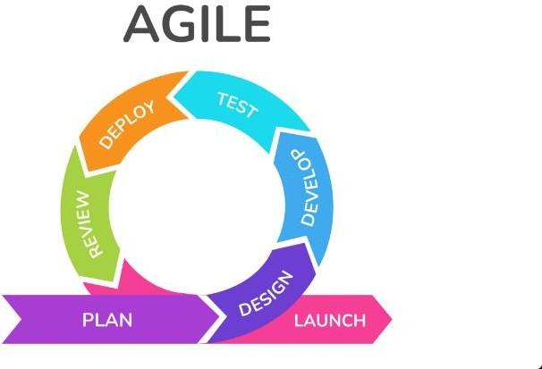Agile methodology will be employed under this project which will give room for gradual advancement and regular feedback. This strategy will be ideal for building the Medical Image Analysis Application. The iterative cycle of planning, design, implementation, testing, documentation and deployment will allow gradual improvements in the system to ensure its compliance with the changing expectations and requirements of the healthcare community.

Figure 2 Methodology

###### PLANNING

In the planning of my project, it entails to seek to draft the objectives, scope outline and major milestones in developing the Medical Image Analysis application. The second stage will have a detailed analysis carried out on what is required as far as crucial feature and functions for proper cancer diagnosis in medical imaging. Moreover, An in-depth examination of available literature and technologies for medical image analysis as well as the development of applications. It will entail identifying user stories as well, setting a project deadline, allocation of resources, and a plan for communication.

###### ANALYSIS AND DESIGN

During the design step, it entails converting these knowledge elements to a practical framework that will enable us to create an operational medical image analysis application. Detailed architectural and system design documents will be crafted outlining the architecture, components as well as interactions within the Application system. UI and UX design are given high priority to facilitate easy time usage by doctors. Data models definition, image recognition and preprocessing algorithms selection into this process are included.

###### IMPLEMENTATION

The medical image analysis application will then be coded into an operational software, during its development state. Based on design specification, this stage will entail developing code, implementing image recognition algorithms, data pre-processing of medical images dataset and designing simple graphical user interface. Having prepared the datasets, model training will occur using the chosen machine learning algorithms to ensure accurate discrimination and classification of those tumors that are thought be pre-cancerous, always enhancing the models.

###### TESTING

The medical imaging analysis application’s testing phase in our agile development cycle will be based on rigorous reviewing and verification methods aimed at ensuring its precision, correctness and reliability. The validation of the whole systems will be done through comprehensive testing which includes unit testing, integration testing, and system testing. Performance assessment of the application shall be performed for different circumstances on real-world medical image datasets with varying sensitivity, specificity, and accuracy. User acceptance testing will form part of testing phase with a view of getting user inputs such as user interface, natural language processing among other aspects is up to the required standards.

###### DOCUMENTATION AND DEPLOYMENT

In this phase of the agile methodology approach, the medical image analysis application that is now ready for use. At the same time, detailed documentation in form of user manual and technical guide for the use of the application will also be made ready to ensure smooth adaptation by its users. The documentation will detail how one can interface with the application among other things such as uploading of medical images, interpretation of results and clarification. Users who use the application will receive clear guidelines on maintenance and troubleshooting in order to make correct use of the system.

# **CHAPTER FOUR: SYSTEM ANALYSIS AND DESIGN**

## Overview

This chapter captures the requirements necessary for the effective functioning of the system, the tools used, and outlines a detailed design of the system. It will also analyze and evaluate the system to determine whether it meets the user’s requirements and objectives of the study.

## System Analysis

This chapter presents a comprehensive analysis of the system, including functional and non-functional requirements, system architecture, data management, machine learning and image processing components, user interface and visualization, integration and deployment, security and compliance, testing and quality assurance, and maintenance and support.

#### Feasibility Study

* + - 1. *Technical Feasibility*

This technical feasibility study examines the viability of developing a medical image analysis application for a fourth-year Bachelor of Science in Computer Science project. The focus is on cancer classification and segmentation, without the requirement for system integration.

Key Components

* + - * + Machine Learning Technologies: The project will leverage TensorFlow or PyTorch, which are leading libraries for deep learning. These libraries are essential for developing the image classification and segmentation models needed for analyzing medical images for cancer detection.
        + Development Tools and Frameworks: The application will be developed using Dart and Flutter. This choice supports the goal of creating a cross-platform application that can run on both mobile and desktop platforms. Dart and Flutter are known for their ease of use, robust documentation, and active community support, making them suitable for a final year project.
        + Database and Backend Services: Firebase will be used for database storage and backend services. It offers a scalable NoSQL database solution (Firestore) that can store and sync data in real time, which is useful for handling user data and processing results. Firebase's free tier is adequate for the scope of the project, providing cost-effective database solutions.
        + Computational Resources: Given the complexity of processing medical images, platforms such as Kaggle could be considered for additional computational resources, especially for training deep learning models.
        + Data Security: Firebase offers built-in security features that can be configured to protect user data.
      1. *Financial Feasibility*

The financial feasibility of developing a medical image analysis application for a fourth-year computer science project is highly favorable, given the exclusive use of open-source tools and platforms. Utilizing TensorFlow or PyTorch for machine learning, Dart and Flutter for application development, and Firebase for backend services incurs no direct costs due to their free access models. Kaggle's provision of free computational resources for model training further mitigates potential financial burdens. While minimal miscellaneous costs may arise, such as internet usage or cloud storage expansion, they are negligible and typical for computer-based projects. This approach ensures the project remains economically viable within the academic framework, devoid of significant financial constraints.

*4.2.1.3 Schedule Feasibility*

The project timeline has been carefully evaluated to determine its practicality within the scope and resources of our initiative. A comprehensive project schedule, detailed in Appendix 1, outlines each phase of development, from inception through to deployment. This includes allotted timeframes for the collection of medical imaging datasets, machine learning model development, and user interface creation, among other key activities. It also incorporates buffer periods to account for potential unforeseen delays, ensuring a realistic and flexible approach to project management. The schedule feasibility hinges on our ability to adhere to this timeline, balancing efficiency with thoroughness to achieve our objectives within the set deadlines.". This is as depicted in Appendix C.

* + - 1. *Operational Feasibility*

The operational feasibility of the medical image analysis application for breast and brain cancer classification and segmentation is centered around its integration within the healthcare environment and its alignment with user needs. The application is designed for healthcare professionals, providing a user-friendly interface developed with Flutter and Dart to ensure cross-platform compatibility and ease of use. Leveraging Firebase for backend services allows for secure, scalable data management and real-time insights, essential for supporting diagnostic processes. This feasibility analysis confirms that the application will not only fit well within existing operational workflows but also enhance the diagnostic capabilities of healthcare professionals, indicating a positive impact on overall operational efficiency and patient care outcomes.

#### Requirements Analysis

The chapter on Requirements Analysis aims to collect, analyze and define what the application should achieve through the process of systematically gathering and specifying the requirements. Through this fundamental task we will be able to grasp the whole idea of medical image analysis and this knowledge will help us during design and implementation phases to determine that the solution we will create is both technically available and valuable for practical use.

The table below dictates how the requirements analysis was done:

*Table 1 Requirement Analysis*

|  |  |  |  |  |
| --- | --- | --- | --- | --- |
| **Data Collection Method** | **Source of Data Collected** | **Preparation** | **Process** | **Output** |
| Research and Review of Existing Documents | Various scientific publications and online repositories (e.g., document on “Deep learning for multi-class semantic segmentation enables colorectal cancer detection and classification in digital  pathology images”) | Identification of relevant documents through academic databases e.g., **nature.com** and search engines. | Reviewing literature on cancer segmentation and classification models, including methodologies, outcomes, and advancements. | Compilation of insights and methodologies from documented research on cancer segmentation and classification, aiding in model development. |
| Viewing of previous public interviews made | Citizen Tv media YouTube video under the Title “The Big Conversation, State of Cancer in Kenya” | Identification and evaluation of relevant interviews through platforms such as YouTube and healthcare  blogs for | Analyzing interviews to gather insights on cancer patient experiences, challenges in diagnosis, and potential areas of  application | Insights on user requirements and the impact of cancer diagnosis methods on patients and healthcare professionals, guiding application.  design to better meet |

|  |  |  |  |  |
| --- | --- | --- | --- | --- |
|  |  | interviews  conducted with patients | improvement. | user needs. |
| Researching and Reviewing Existing Datasets | Breast Ultrasound Images Dataset and Brain MRI Images for Brain Tumor Detection both publicly available in Kaggle under the following links: [Breast Dataset](https://www.kaggle.com/datasets/aryashah2k/breast-ultrasound-images-dataset)  [Brain Dataset](https://www.kaggle.com/datasets/navoneel/brain-mri-images-for-brain-tumor-detection) | Evaluation of dataset quality, relevance to project objectives, and preparation required (e.g.,  cleaning, labelling). | Reviewing datasets, analyzing image characteristics, and preprocessing data to suit model training requirements | Prepared datasets of breast ultrasound and brain MRI images, ready for use in training and validating the cancer classification and segmentation models. |



Figure 3Evidence of Interview of cancer state and discussion

#### Requirements Specification

The Requirements Specification chapter outlines the essential functionalities, system capabilities, user roles, and expectations that will guide the creation of a tool designed to revolutionize the diagnostic process for radiologists. Through a comprehensive analysis of both functional and non-functional requirements, this specification ensures that every feature of the application aligns with the goal of enhancing diagnostic accuracy, efficiency, and user experience. It encompasses the application's core capabilities, from secure user authentication and intuitive dashboards to advanced image processing and insightful reporting, all while adhering to stringent security and performance standards. By laying down a clear, detailed foundation for what the application must achieve and how it will operate, this chapter acts as a cornerstone for the development team, stakeholders, and users, ensuring a cohesive and focused approach to tackling one of the most pressing challenges in healthcare technology today.

##### Functional Requirements

1. Image Upload: The system will allow healthcare professionals such as radiologists to upload medical images (MRI scans and mammograms) in common file formats (e.g., DICOM, JPEG, PNG).
2. Image Classification: The system will be able to classify uploaded images as cancerous or non-cancerous for brain and breast cancer cases.
3. Image Segmentation: For images classified as cancerous, the system will be able to segment and delineate the cancerous regions within the image.
4. Visualization: The system will provide visualization tools to display the original image, the classification result, and the segmented cancerous regions.
5. Reporting: The system will generate comprehensive reports summarizing the classification and segmentation results, along with relevant patient information.
6. User Management: The system will support user authentication and authorization mechanisms to ensure data privacy and security.
7. Data Handling and Storage: All patient data and diagnostic results must be securely stored in a database that will offer data integrity and confidentiality during storage.

##### Non-Functional Requirements

1. Performance: The system will be able to process and analyze medical images in a reasonable time, ensuring efficient diagnosis and treatment planning.
2. Scalability: The system will be designed to handle increasing volumes of data and user demands without significant performance degradation.
3. Accuracy: The classification and segmentation algorithms will achieve high accuracy levels, meeting or exceeding industry standards and clinical guidelines.
4. Usability: The user interface will be intuitive and user-friendly, requiring minimal training for healthcare professionals.
5. Security: The system will implement robust security measures to protect patient data

## System Design

#### Architectural Design

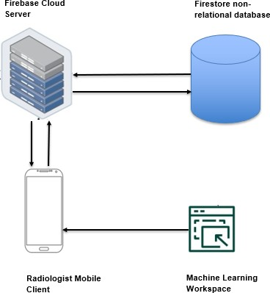

Figure 4 System Architecture

##### Architecture Overview

The architecture is structured to facilitate a mobile-based medical image analysis application designed for use by radiologists. It comprises several interconnected components that work together to enable the processing and analysis of medical images for cancer detection.

##### Components Description

1. Firebase Cloud Server:
   * Serves as the backend server for the application.
   * Provides a range of cloud-based services including authentication, database management, and storage solutions.
   * It acts as the central node that interfaces with both the client application and the database. 2.Firestore Non-relational Database:
   * A NoSQL database provided by Firebase that stores and syncs data in real-time.
   * Used for storing patient information, medical image metadata, analysis results, and generated reports.
   * Offers flexible, JSON-like document storage that supports a real-time data synchronization service for app state management.
2. Radiologist Mobile Client:
   * The frontend of the system where radiologists interact with the application.
   * Enables users to log in, manage patient data, upload medical images, and view analysis results and reports.
   * Communicates with the Firebase Cloud Server for various services, including retrieval and storage of data.
3. Machine Learning Workspace:
   * A separate environment, possibly provided by services like Kaggle, where machine learning models are trained and developed.
   * Hosts the medical image analysis models which perform tasks such as classification and segmentation of medical images.
   * Once trained, the model is integrated into the application’s workflow, likely through the Firebase Cloud Server.

**Workflow Description**

* + Radiologists use the Mobile Client to upload medical images to the Firebase Cloud Server for analysis.
  + The server processes the image uploads and interacts with the Machine Learning Workspace to classify and segment the images.
  + Analysis results are returned to the mobile client for visualization and further review by the radiologist.
  + Patient data, along with analysis results and generated reports, are stored in the Firestore Database for persistence, historical tracking, and future reference.
  + Throughout this process, Firebase provides additional services such as user authentication, ensuring that only authorized users can access sensitive patient data and analysis results.

#### Process Design

The process design outlines the core processes and workflows involved in the medical image analysis application. It describes the sequence of activities and interactions between the various components of the application to achieve the desired functionality.

###### *High Level Design*

The following diagram illustrates the overall high level block diagram of the system.

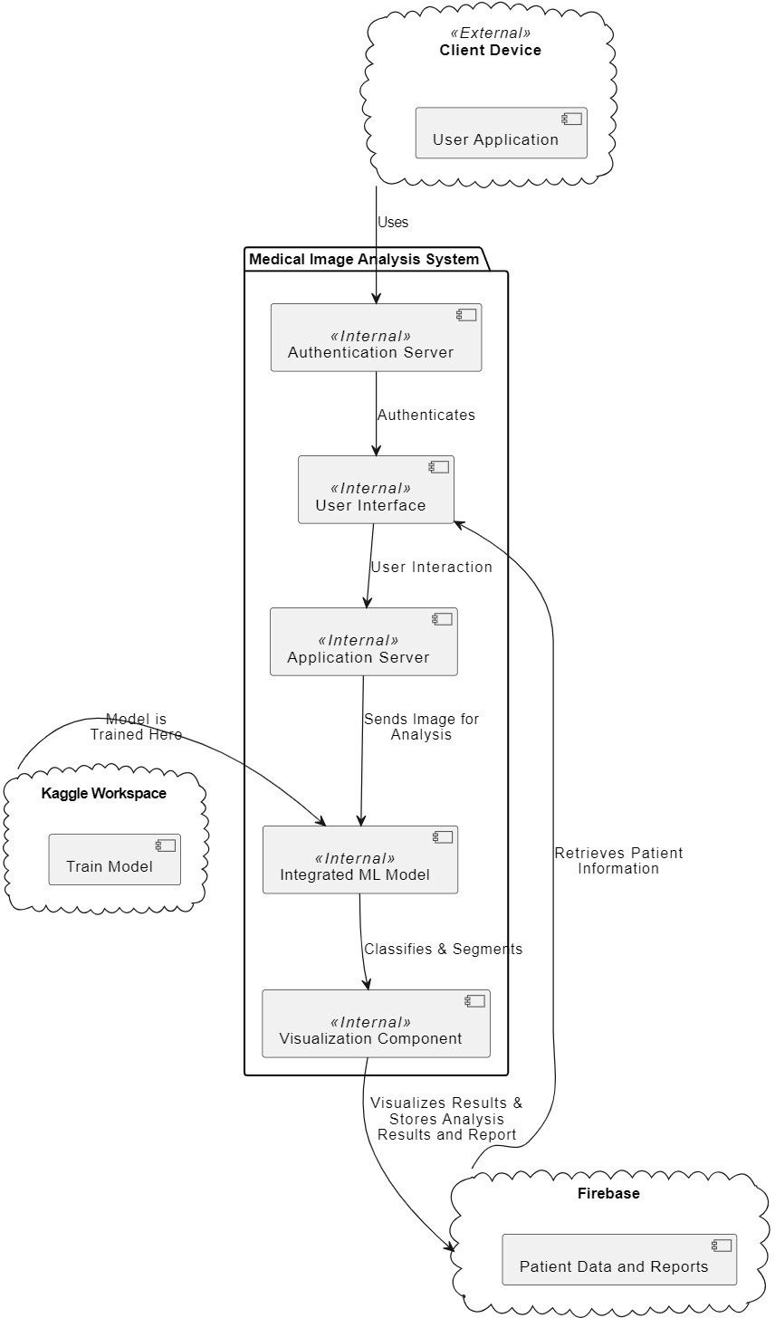

Figure5HighLevelDesign

###### *Medical Image Processing Workflow*

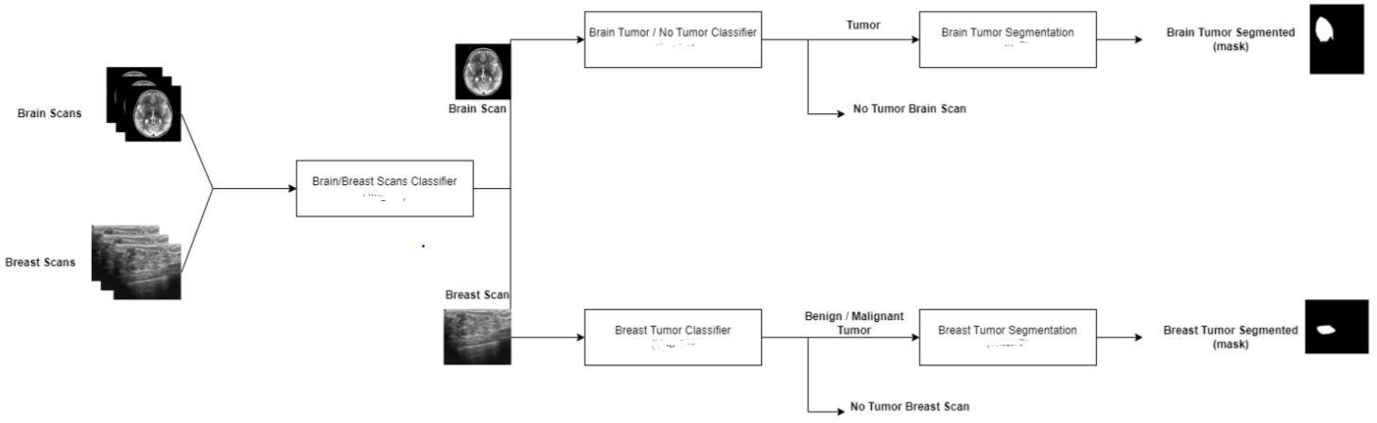

Figure 6 Medical Image Processing Workflow

The depicted workflow in the above picture is an efficient work process for the medical image analysis for the identification and division of tumors in brain and breast scans. The procedure commences with a medical scans input, this is then split into two paths, where one is then used for classification. This system utilizes specialized classifiers: One for brain scans, which would discover the presence of a tumor, and another for breast scans, to tell whether a tumor is benign or malignant.

The workflow subdivides at classification stage where the flow structuring depends on the initial assessment. Subsequently, when tumors have been detected, the scans are then segmented by more specialized algorithms that outline the margins of the tumor using the resulting mask which is a highlighted area of the tumor within the scan. This is key for defining the exact location, which can be used to guide treatment decisions.

For both scans that do not show tumor in brain and scans classified as not having tumor in breast, the workflow ends just without segmenting. The finished work generates sheets of masks that can be the more concrete pictorial help among physicians for diagnostic, treatment and planning purposes.

###### *Flowchart*

The diagram below represents flowchart diagram that illustrate the sequence of steps or processes involved in the system. The purpose of these diagrams is to provide a visual representation of how the process works. By following the various shapes and symbols in the flowchart, we can see the flow of information, decision points and actions taken at each stage of the process and help visualize complex processes to make them easier to understand.

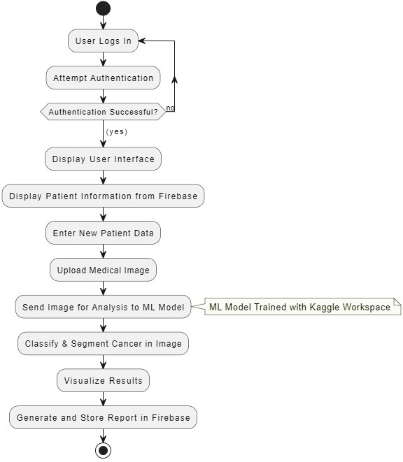

Figure 7 Flowchart

#### User Interface

###### Use Interface Design

This is where the user interfaces for the radiologists were designed, that visually illustrates how the implementation will supposed to look like.

*Mobile Application design*

Login and Signup Forms

Here is where the radiologists must enter their credentials for authentication and authorized access to the application and its services.



Figure 8 Login Page

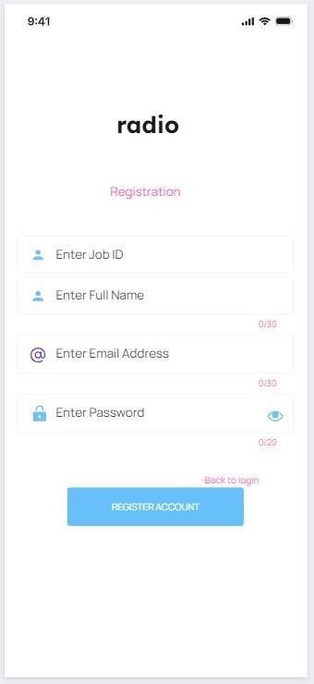

Figure 9 Registration Page

User Profile Page

Below is the users profile page where he can be able to update his credentials. Providing user information and account management options.

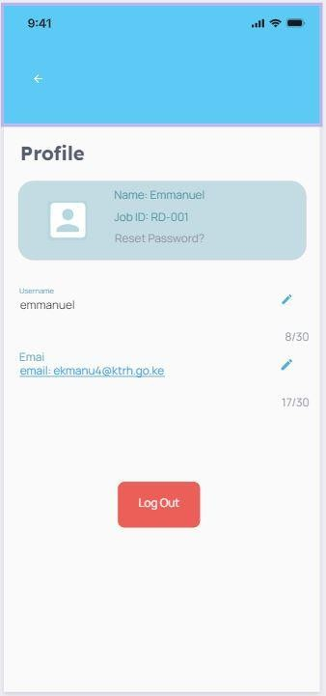

Figure 10User Profile Page

Home Page

Below is the homepage serving as the central hub offering two primary options: Patient Information and Diagnosis.

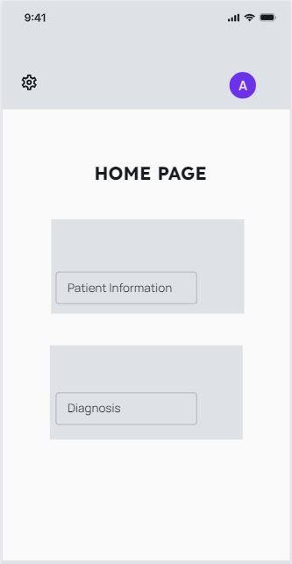

Figure 11 Home Page

Patient Information Page

This page offers patient demographics and medical diagnosis history in report form tied to each patient.

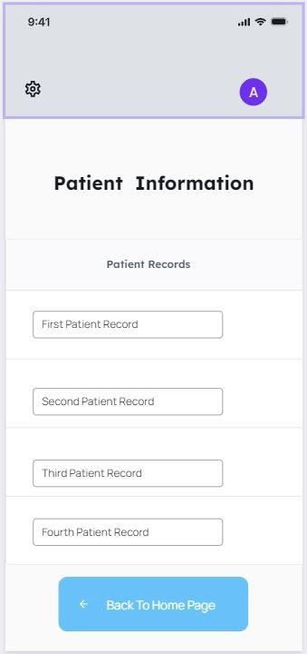

Figure 12 Patient Information Page

Patient Details Page

This page is under the diagnostics tab in the home page. User(radiologist) has to enter each patient detail before diagnostics starts.

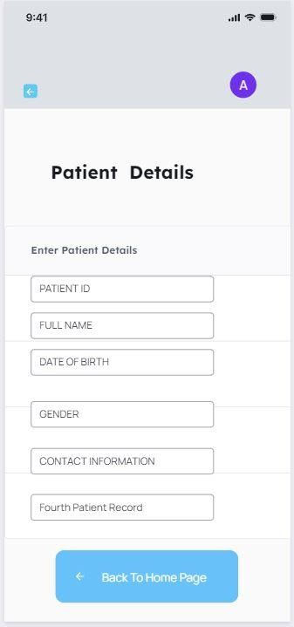

Figure 13 Patient Details Page

Diagnostics Page

Below is the diagnostics page for the medical application, specifically tailored for uploading and analyzing medical images for cancer diagnosis. Where users can upload new medical images for scanning.

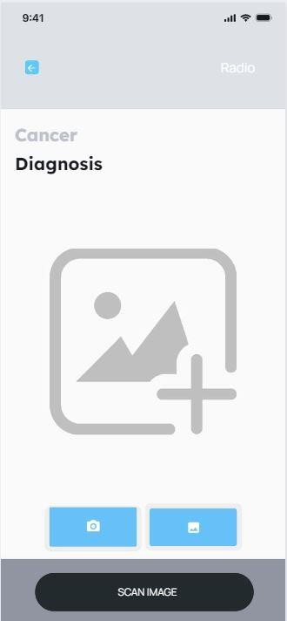

Figure 14 Diagnostics Page

Analysis Page

The screen below is the 'Analysis and Visualization' page of the application, where the outcomes of the uploaded medical images are processed for cancer classification and segmentation.

At the bottom, the 'GENERATE REPORT' button suggests that once the analysis is complete, the user can compile the findings into a formal report, presumably including both the classified data and segmented images.

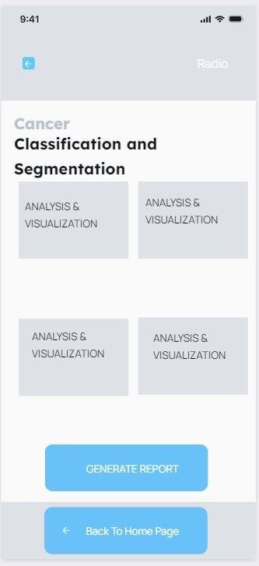

Figure 15 Visualization Page

###### *Use Cases*

This segment elaborates on how users interact with the system to achieve specific goals, focusing on the radiologist's workflow, from logging into the system to reviewing analysis reports. It outlines the main scenarios in which the system will be used, detailing the steps involved in each process and how the interface supports these activities.

The table below depicts the use case.

*Table 2 Use Cases*

|  |  |  |  |
| --- | --- | --- | --- |
| Use Case Scenario | Actors | Goal | Steps |
| 1. User Authentication | Healthcare User | To log into the system securely. | 1. Open the application. 2. Enter credentials. 3. System verifies credentials. 4. If successful, direct to home page 5. If failed, prompt to retry. |
| 2. Retrieve Patient Information | Healthcare User, Firebase | To access existing patient data. | 1. Navigate to patient information section. 2. System retrieves data from Firebase. 3. View patient |

|  |  |  |  |
| --- | --- | --- | --- |
|  |  |  | information. |
| 3. Enter New Patient Data | Healthcare User, Firebase | To enter new patient data into the system. | 1. Select to add new patient data. 2. Enter patient details. 3. System stores data in Firebase. |
| 4. Upload and Analyze Medical Image | Healthcare User, Integrated ML Model | To upload a medical image for analysis and receive results. | 1. Navigate to diagnostics section. 2. Upload medical image. 3. Send image to ML model for analysis. 4. Display analysis results. |
| 5. Visualization and  Report Generation | Healthcare user,  Visualization Component, Firebase | To visualize analysis  results and generate a report. | 1. Use visualization.   part to display results.   1. Review   visualization.   1. System generates report. 2. Store report in Firebase. |
| 6. Review Stored Reports | Healthcare user, Firebase | To review previously generated analysis reports. | 1. Navigate to reports section. 2. System retrieves reports from Firebase. 3. Select and review a report. |

###### *Use Case Diagra**m*

Figure 16 Use Case

Machine Learning Workspace



#### Database Design

This section delves into the structured planning and organization of the data resources that are essential for supporting the system's functionality, ensuring efficient data storage, retrieval, and management. It involves defining the data entities relevant to the system, such as users, patient information, medical images, analysis results, and reports.

###### *Entity Relationship Diagram*

A visual representation of the data model, illustrating the entities, their attributes, and the relationships among them. The ERD serves as a foundation for developing the database schema, easing a clear understanding of the system's data requirements.

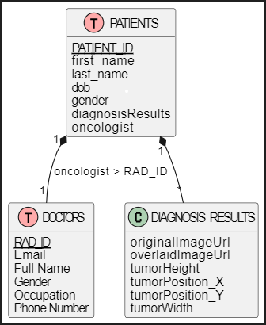

Figure17Database#Design

# **CHAPTER FIVE: SYSTEM IMPLEMENTATION**

## 5.1 Chapter Overview

This chapter provides information on the activities which will be undertaken in order to implement the system that is to be used for analysis of medical images, particularly for identification of brain and breast cancer. It describes the type of computer environments involved in the implementation of the project design as well as the application and setting methods of forming a operational system.

## . Hardware and Software Requirements

#### 5.2.1. Hardware Requirements.

* **Laptop:** It was solved using a laptop whose minimum requirement was 4GB RAM and 256GB storage to solve the software tools and large data of the datasets.
* **Connection:** High and stable Internet connection became an inalienable necessity for connecting to the cloud services, deploying an application, getting updates and dependent packages from the Internet.

#### 5.2.2. Software Requirements.

###### *5.2.2.1. Programming Languages.*

* **Python**: They are employed for building machine learning models within the Kaggle environment by such libraries as TensorFlow for deep learning.
* **Dart**: For the contribution it offers when integrated with the Flutter framework that is used in the development of the front-end part of the application’s user interface, it is known to increase its fluidity.

###### *5.2.2.2. Frameworks and Platforms.*

* **Flutter**: Hired for architectural work of enhancing good working relations between a mobile application and a desk-based application.
* **Kaggle Workspace:** Supposing the computational resource that is implied with training the machine learning models which are available for use by the GPUs.

###### *5.2.2.3. Development Environment.*

* **Visual Studio IDE**: Used for all the programming activities; a stable ground for coding and developmental applications can be found here.

###### *5.2.2.4. Data Storage Solutions.*

* **Firebase Realtime Database:** Applied where in the processing or storing of data, a real-time information interchange is necessary especially between interfaces.
* **Firebase Storage:** At times, it is applied for purposes of both storage and retrieval of big files such as patients’ medical images securely.

## . Implementation Results

The implementation process involved two major parts:

* Model Development and Training
* Application Development

#### Model Development and Training

The development of the machine learning models for both brain and breast cancer identification and segmentation involved the following specific models and methodologies:

###### *5.3.1.1. Brain and Breast Scan Classifier Model*

The Model can differentiate between the scans of the brain and the breast hence the images are appropriately referred to the right specialized diagnostic models. The model’s development included:

* **Data Preparation**: Raw data contained images where subjects were classified according to whether the image was of the brain or breast scans; images were preprocessed to bring to a common size, and all images similarly scaled. **Model Architecture**: CNN architecture that aims at sorting the two types of medical images according to the features that set them apart.
* **Training and Evaluation:** The classifier was trained on the brain and breast scans’ mixed dataset and then evaluated based on accuracy to determine its efficacy.

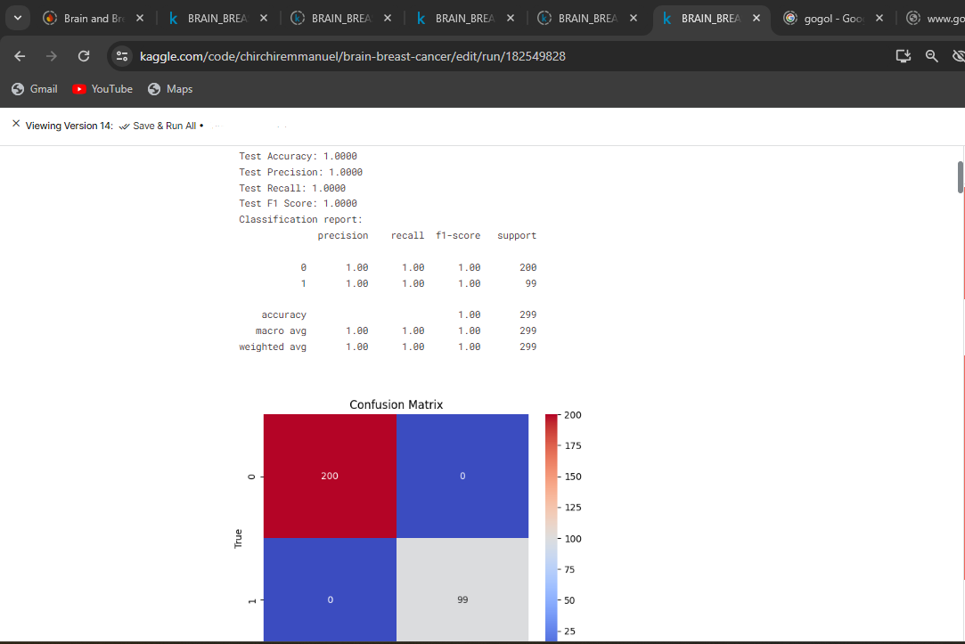

Figure 18 Metrics for the brain and breast scan classifier model

Figure 19 Results of the Brain and Breast scan classifier model

###### *5.3.1.2. Brain Tumor Classifier Model*

The model is used in the analysis of the images of the brain scans to determine if they consist of a tumor or not to enable treatment. Model development included:

* **Data Preparation:** The model took data obtained from the images of the brain scans, which were classified as ‘Tumor’ or ‘No tumor’. Pre-processing of data included scaling down images and encoding them to standard sizes as well as making their pixel intensities zero-centered.
* **Model Architecture**: To accomplish the classification of the images, a convolutional neural network was used with layers namely Conv2D, MaxPooling2D, and Dropout used to extract features and prevent overfitting.
* **Training**: In the process of training of the model, the dataset was divided between the training dataset and the test dataset to ensure independence and the efficiency of the model was conducted of various features used to classify brain tumors.

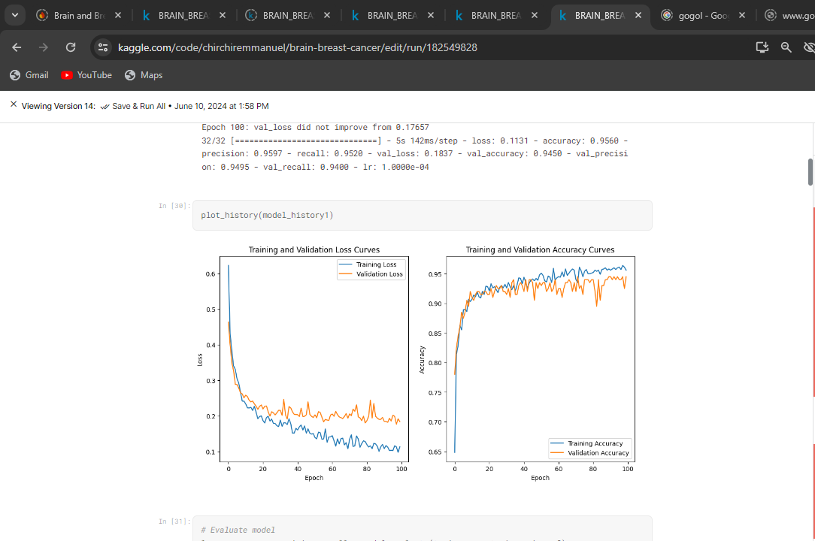

Figure 20 Training metrics for Brain Tumor Classifier model

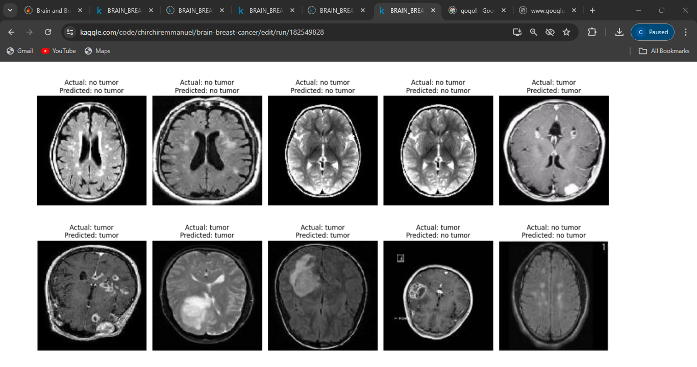

Figure 21 Results of the Brain tumor classifier mode

###### *5.3.1.3. Breast Tumor Classifier Model*

In the case of assessing breast scans, the model will help in the classification of the scans into ‘benign’, ‘malignant’ or ‘normal’ hence facilitating the diagnosis of breast cancer. Model development included:

* **Data Handling**: Original and extracted images were preprocessed; this involved resizing and normalizing the images color intensity.
* **Model Design**: A CNN tailored with intricate patterns which are significant for tumor classifications in scans of the breast.
* **Training and Validation:** Training with validation allays the model’s adequacy and feasibility since an immature model could harm the patient or worsen their condition.

Figure 22 Metrics for the breast tumor classification model

Figure 23 Results of the Breast Tumor classification model

###### *5.3.1.4. Brain Tumor Segmentation Model*

The model can detect boundaries of the tumor in scans of the brain that will help in preparation for surgery and direct treatment. Model Development included:

* **Data Preparation:** MRI brain images were in this study disposed to a standard space and normalization of the image achieved to make it possible to compare the images in the database. Every image was accompanied by a segmentation mask where the tumor was highlighted.
* **Model Architecture:** Utilized U-Net architecture is one of the best architectures for segmenting medical images. The contextual and localization information are processed by the contracting and expanding path of U-Net to obtain the optimal outline of the tumor at different scales.
* **Training Strategy:** Used Dice coefficient loss to optimize the number of tumor segments detected by the model and the actual tumor segments. Some pre-processing methods like rotation of the images and scaling were used as ways of increasing model resilience.
* **Optimization and Validation**: These adjustments included performance metrics like Dice scores that showed the model’s refinement in training; another adjustment was the learning rate, hyperparameter adjustments that handled the instance of overfitting.

Figure 24 Training and Testing Metrics for brain segmentation model Metrics

Figure 25Results of the Brain tumor Segmentation Model

###### *5.3.1.4. Breast Tumor Segmentation Model*

In breast scans, the model can outline the exact area to be affected by the tumor in order to help surgery and therapy. Model development included:

* **Data Preparation**: The mammography images used in this study were obtained from digital mammography archives; Source images were then preprocessed for size normalization and intensity standardization. Both were coupled with segmentation mask to delineate the cancerous tissues. **Model Architecture**: Used the variation of U-net known as modified U-net that has been designed mainly for the segmentation problems because it provides high efficiency in terms of spatial hierarchy and/or fine details in medical images.
* **Training Strategy**: Fine-tuned using binary cross entropy and Dice loss for segmentation accuracy and emphasis on improving the tumor boundary of the tissues. For data augmentation, flipping and zooming was performed to improve the model’s ability to handle various ways images can be presented.
* **Optimization and Validation**: The efficiency of the models was checked on a regular basis with the help of validation criteria, i. e. Dice score and specificity. According to these metrics, minor changes were made to the model parameters to fit better to unseen datasets.

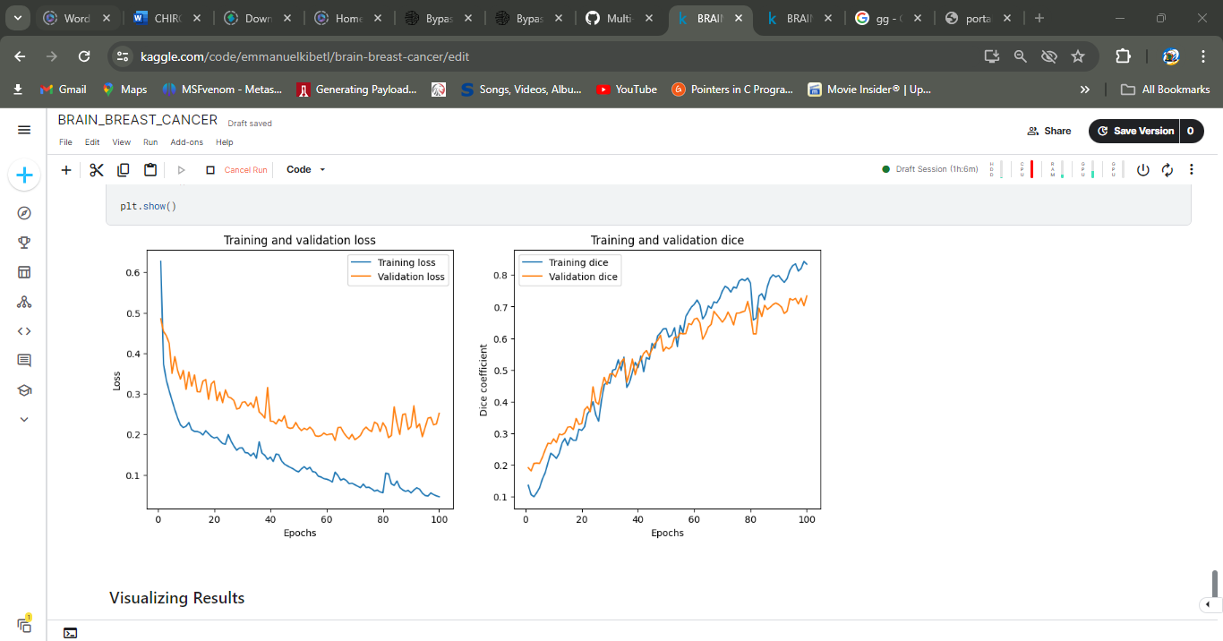

Figure 26 Training metrics for the breast cancer tumor segmentation model

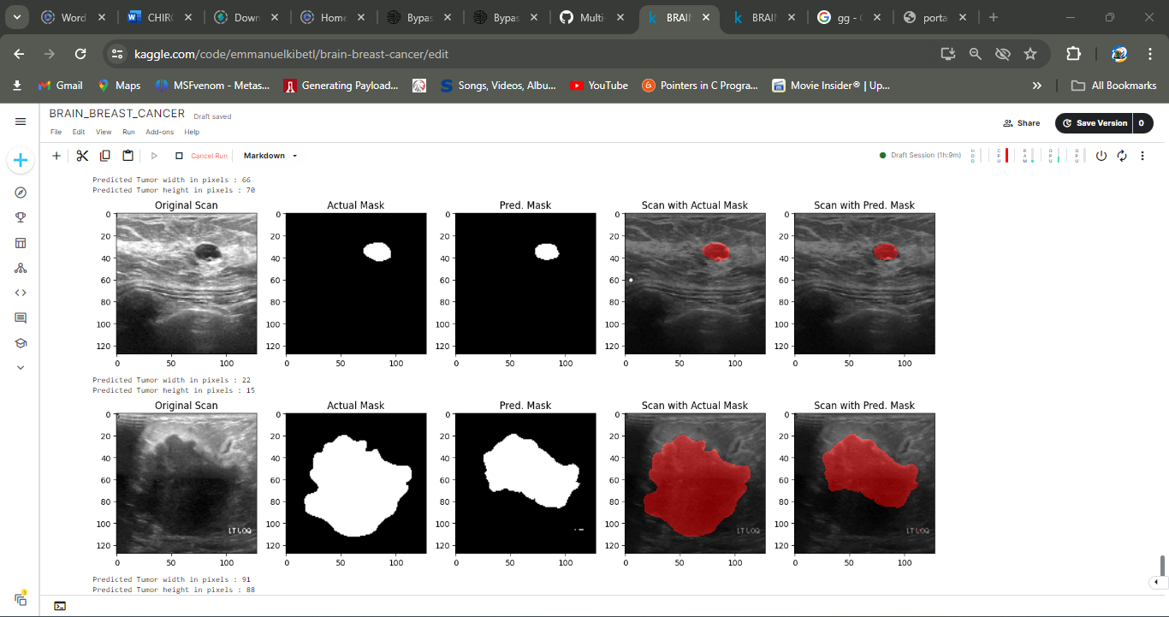

Figure 27 Results of the Brain cancer tumor segmentation model

#### Application Development

The development of the application aimed at building a user-centric interface for interacting with the cancer detection and segmentation models. This section outlines the key aspects of the application development process.

###### *5.3.2.1 Front End Development*

* **Technology:** Dart programming language along with the Flutter framework was used in design and development of the application front-end. Such decision was made because Flutter produces applications with native performance and it’s cross-platform, that means the application can run on both IOS and Android.
* **User Interface Design:** The design for ease of use was mere importance in its design, such that extremely low skilled health care practitioners could easily understand the application. Buttons, sliders, and other gadgets with corresponding animation are included into the UI to show the analysis of the brain and breast scans results.
* **Interactive Features:** Features which were integrated include image upload functionality which enables the users to upload brain or breast scan images into the application. The application then must go back to the backend to have processed these images and get the results.
* **Responsive Design:** Made certain that the application has consistent and efficient usability across all devices ranging from large screen size to the small one and the devices are in both portrait and landscapes orientations.

Figure 28 Application Development

###### *5.3.2.2 Back End Development*

* **Server-Side Logic:** Being developed with Python, where the application used Flask framework for requests handling from the frontend. Flask was adopted for its lightweight and the fact that it can be effortlessly connected to Python-built machine learning algorithms.
* **API Development:** It is important to know that before the advancement of RESTful APIs, frontend and backend applications could not communicate very well. These APIs are responsible for some functionalities like receiving data in the form of an image, passing it through the machine learning models and returning the prediction.
* **Data Handling:** Implemented the Firebase Realtime Database as a data storage for the users and the produced analysis results. Such a structure makes it possible to update and retrieve information in view of the users’ needs to be given feedback instantly.

Figure 29 Model Server logic side

Figure 30 Database implementation

## System Testing

#### 5.4.1. Unit Testing.

This refers to the process of testing individual units of an application that need to be integrated with other related units to form a complete application. In more detail, on this project, unit tests were performed for every desirable module to check the functionality of that certain module and to check its reliability as well. The testing process focused on the following key components: The testing process focused on the following key components:

* **Login Module:** This is the login functionality which provides right credentials for a user and then log them in.
* **Personal Manager Module:** Checks the ability to retrieve and present patient’s records and create medical documents.
* **Diagnostics Module:** Checks whether the correct input and processing of the diagnostic results are possible, as well as their correct display.

#### 5.4.2 Test Cases

The following is a detailed table showing specific test cases that have been created to confirm the fundamental operations of the application. It also comprises of cases for submitting diagnostic data, dealing with errors and visualization of outcomes. Each test case is defined by a unique ID and includes a description of the test, input data, the expected outcome, and the actual outcome after testing: Each test case is defined by a unique ID and includes a description of the test, input data, the expected outcome, and the actual outcome after testing:

|  |  |  |  |  |  |
| --- | --- | --- | --- | --- | --- |
| **Test Case ID** | **Module** | **Description** | **Input** | **Expected Outcome** | **Actual Outcome** |
| TC01 | Login | Test valid user login | Valid username and password | Redirect to homepage with tabs | As expected |
| TC02 | Login | Test invalid user login | Invalid username or password | Error message and stay on login page | As expected |
| TC03 | Personal Manager | Access patient records | Click on Reports button | Display all patient records | As expected |
| TC04 | Personal Manager | Generate patient medical report | Select a patient and generate report | Downloadable medical report generated | As expected |
| TC05 | Diagnostics | Submit patient scan for diagnostics with valid data | Valid brain or breast scan upload | Diagnostic results automatically displayed and saved in database | As expected |
| TC06 | Diagnostics | Submit incorrect patient information | Incorrect patient details | Display error message, prompt for correct data | As expected |
| TC07 | Diagnostics | Submit unsupported scan format | Unsupported file format upload | Display error message and request valid file format | As expected |
| TC08 | Diagnostics | Visualization of diagnostic results without user interaction | Submit valid scan for diagnosis | Results automatically processed and visualized on the interface | As expected |

# **CHAPTER SIX: CONLUSIONS AND RECOMMENDATIONS**

## 6.1 Chapter Overview

This chapter provides a VIEW of the project's outcomes. It highlights the key achievements and draws conclusions from the project activities. Finally, it offers recommendations for further work to enhance and expand the project's capabilities.

## 6.2 Achievements

The successful completion of this project has resulted in a medical image analysis application for brain and breast cancer detection for the case of healthcare organizations. The successes achieved by the implementation of this project are based on whether the system objectives are meet in which are:

* **Comprehensive Requirement Gathering:** Detailed requirements were able to be gathered, thus ensured the developed application met the expectations and needs of healthcare professionals.
* **Data Collection and Curation:** Managed to collect and effectively curate extensive medical imaging datasets, which were vital for the training and validation of the machine learning models.
* **Development and Optimization of ML Models**: Developed robust machine learning models for the accurate classification and segmentation of cancerous tissues and optimized these models to achieve high efficiency and performance.
* **User-Centric Interface Design:** Designed and developed a user-friendly interface that facilitates easy navigation and interaction for healthcare professionals, significantly enhancing user experience.
* **Effective Visualization and Reporting:** Implemented visualization and reporting that provide clear and actionable insights to healthcare professionals, aiding in better diagnostic decision-making.
* **Performance Evaluation:** Thoroughly evaluated the application and model across various parameters, confirming its reliability, efficiency, and accuracy in a clinical setting.
* **Comprehensive Documentation:** Produced detailed documentation that captures all aspects of the project development, making it easy for future references and iterations.

## 6.3 Conclusions

The development of this medical image analysis application marks a significant advancement in the utilization of artificial intelligence for healthcare diagnostics. By integrating advanced machine learning models for the classification and segmentation of brain and breast cancer, the application not only enhances diagnostic accuracy but also significantly improves the efficiency of medical professionals.

Furthermore, the project was an enriching learning experience, deepening my understanding of artificial intelligence, data handling, user interface design, and system integration within a clinical environment. It also highlighted the importance of bridging the gap between technical innovation and practical healthcare applications. Successfully navigating the challenges of developing and implementing such a sophisticated tool was immensely rewarding and underscored the profound impact that AI can have on enhancing healthcare services. This project was a significant personal achievement, reinforcing my passion for leveraging technology to solve real-world problems.

## 6.3 Recommendations for Further Work

Despite being able to implement this project, there is more that can be done arising from this project to improve it. For future work, the following areas are recommended:

* **Expand the Dataset:** To improve model accuracy and generalization, expanding the dataset to include more varied and comprehensive cases is crucial.
* **Incorporate Feedback Mechanisms:** Integrate continuous feedback mechanisms from end-users to refine the application and address practical challenges in real-time.
* **Explore Additional AI Techniques:** Investigate the integration of additional AI and machine learning techniques, such as deep learning and neural networks, to enhance the models' diagnostic capabilities.
* **Broader System Integration:** Focus on enhancing the application's integration capabilities with a wider range of healthcare IT systems to increase its adaptability and utility.

# REFERENCES.

1. Nation Africa (2021) 'How Cancer Management is Changing in Kenya'. Available at: <https://nation.africa/kenya/news/how-cancer-management-is-changing-in-kenya-3282742>.

1. MDPI (2023) ‘Automated Contouring and Planning in Radiation Therapy:, Diagnostics, MDPI. Available at: <https://www.mdpi.com/2075-4418/13/4/667.>
2. Radiation Oncology Journal (2021), Radiation Oncology, BioMed Central. Available at: <https://ro-journal.biomedcentral.com/articles/10.1186/s13014-021-01923-1.>
3. Ministry of Health, Kenya 'The Kenya National Cancer Control Strategy (2023-2027)'. Available at:<http://guidelines.health.go.ke:8000/media/NATIONAL_CANCER_CONTROL_STRATEGY_2023-2027_7uTQQP4.pdf>
4. PubMed Central (2021) 'A Systematic Review of Artificial Intelligence Techniques in Cancer Prediction and Diagnosis available at: [https://www.ncbi.nlm.nih.gov/pmc/articles/PMC8475374/.](https://www.ncbi.nlm.nih.gov/pmc/articles/PMC8475374/)
5. PubMed Central (2023) 'The use of artificial intelligence tools in cancer detection compared to the traditional diagnostic imaging methods: Overview of the systematic reviews'. Available at: [https://www.ncbi.nlm.nih.gov/pmc/articles/PMC10553229/.](https://www.ncbi.nlm.nih.gov/pmc/articles/PMC10553229/)
6. Artificial Intelligence Techniques in Cancer Prediction and Diagnosis. Available from: [https://www.ncbi.nlm.nih.gov/pmc/articles/PMC8475374/.](https://www.ncbi.nlm.nih.gov/pmc/articles/PMC8475374/)
7. Convolutional Neural Networks in Medical Image Diagnosis. Available from: <https://www.ncbi.nlm.nih.gov/pmc/articles/PMC10071480/>.
8. Machine Learning in healthcare available at: <https://www.ncbi.nlm.nih.gov/pmc/articles/PMC8822225/>.
9. Tran, K. A., & Nguyen, L. H. (2023). AI-driven predictive models for personalized medicine in oncology. Precision Medicine Journal, 8(2), 118-130. Retrieved from <https://www.ncbi.nlm.nih.gov/pmc/articles/PMC7596234/>
10. Kumar, A., Wong, A., & Bengio, Y. (2021). Advances in Deep Learning for Healthcare Applications. Healthcare AI Journal, 15(5), 241-259. Retrieved from <https://www.ncbi.nlm.nih.gov/pmc/articles/PMC7367612/>
11. Liu, Y., Li, R., & Xu, W. (2022). A Systematic Review of Artificial Intelligence Techniques in Cancer Prediction and Diagnosis. Frontiers in Oncology, 11, 467-480. Retrieved from <https://www.ncbi.nlm.nih.gov/pmc/articles/PMC8475374/>

**APPENDICES**

APPENDIX A: User Manual

This manual embraces all the necessary information concerning the usage of the medical image analysis application that has been developed to diagnose the brain and breast cancer. The feature set of the adduced application includes such features as convenient usage with the option of adding/modifying/ the data regarding patients, including the data of the diagnostic assessment, and generating/operating on the medical reports.

### 1. Logging In

* **Step 1:** Go to the application this match has been installed on the device you are using.
* **Step 2:** In the first interface of the login type, fill in your User ID and Password in the provided blocks. An account has already been set up under the user ID: RAD-001 Password: Laptop12+++
* **Step 3**: Click the “Log In” button to access your account. If you do not have an account, the “Sign Up” button is next to the search bar for you to sign up for one.



Figure 31 Login Page

### 2. Home Page Navigation

* **Personal Manager**: To gain access to this segment, one has to navigate through the home page and click on the Personal Manager that appears on the homepage. This one is specific to managing patient reports and analysis of patient records.
* **Diagnostics:** The diagnostics tab can be selected to bring up a new page and click on the “Diagnostics” button on the page to be taken to the diagnostic area of the application where new patient scans can be processed, and diagnostic results can be viewed.



Figure 32Home Page 1

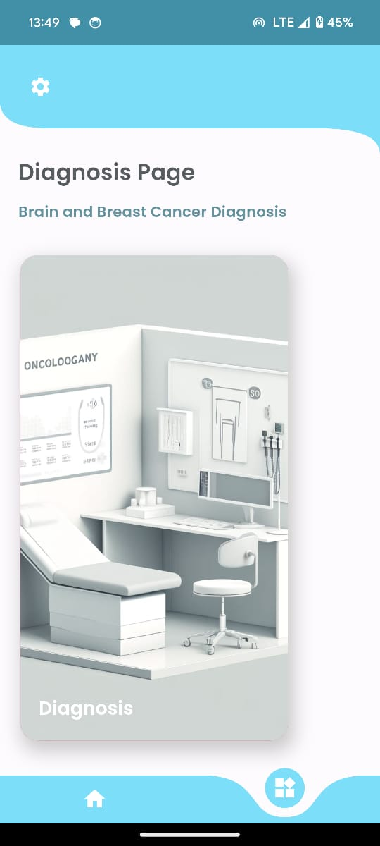

Figure 33 Home Page 2

### 3. Managing Patient Reports

* **Step 1**: When you click on the “Personal Manager” tab, look for the button labeled “Reports.”
* **Step 2:** This action will show patient record database so that everyone who wants to can view all the records of the patients. This is where you can access, view diagnostic reports for all patients

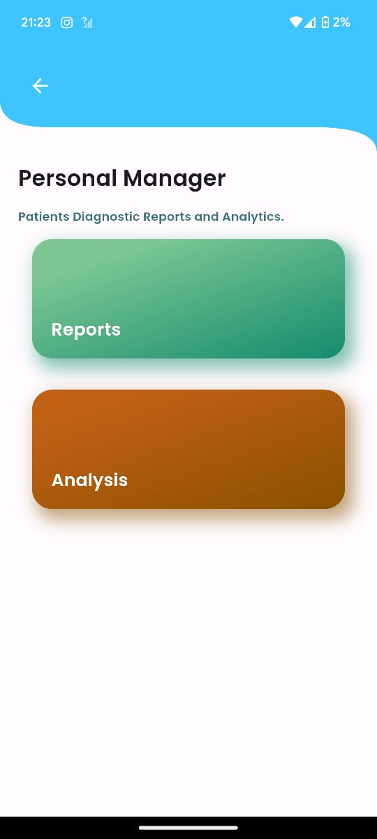

Figure 34 Analysis and Reports Page

.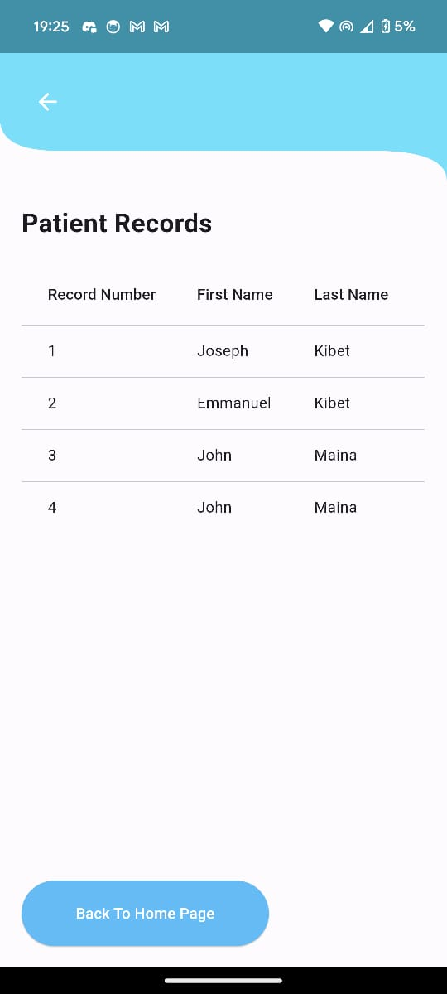

Figure 35 Patient Records page

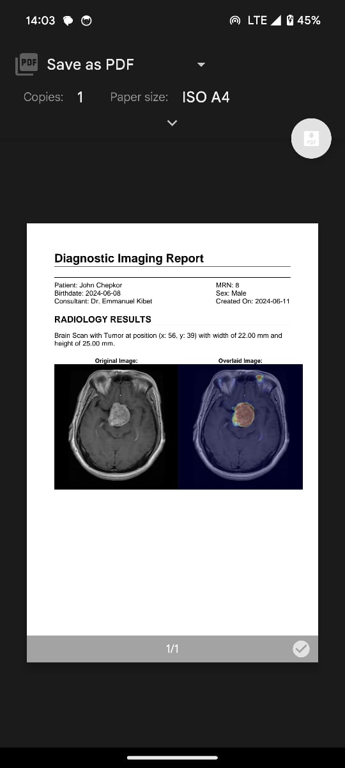

Figure 36 Reports

### 4.Analysis of Diagnosis

* **Step 1:** Next, press the “Personal Manager" tab on the screen, then the “Analysis” button.
* **Step 2**: This action will show all the possible analyses that can be performed on the patient data available: It allows viewing, tracking, and forming diagnoses about every patient.



Figure 37 Reports and Analysis Page

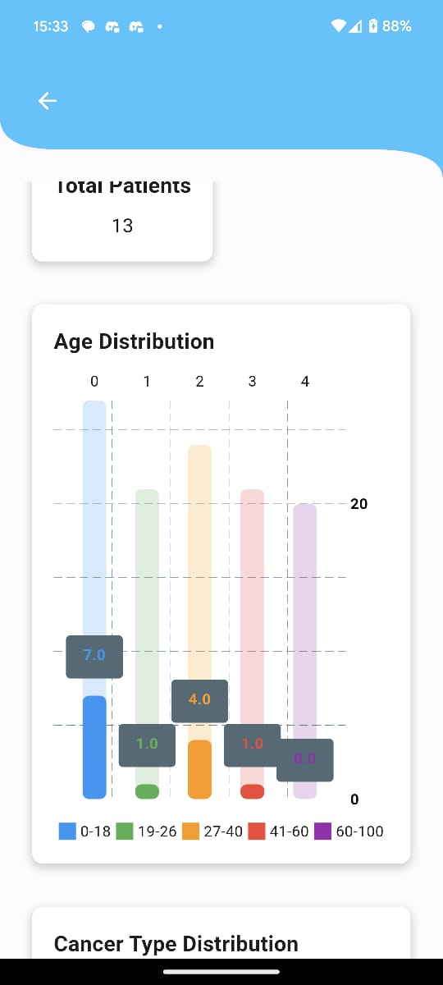

Figure 38 Analysis Page

### 5. Conducting Diagnoses

* **Step 1**: Go to the diagnostics tab, which is located at the center of the home page at the top of the screen.
* **Step 2**: For both new patient registration or registration of a new disease pattern for an existing patient, fill the patient details and the required scan images include the patient’s name, date of birth and the images needed.
* **Step 3:** When entering the details of a patient and uploading the scan, click ‘save patient info’ to continue with the process.
* **Step 4**: Employing the uploaded scans through the incorporated AI models, the application will be able to detect and segment any discovered tumor as being cancerous.
* **Step 5:** After the analysis the results will be shown on the screen along with images like spectroscopy of the scanned area; in this some parts will be shaded depending on the tumor density.

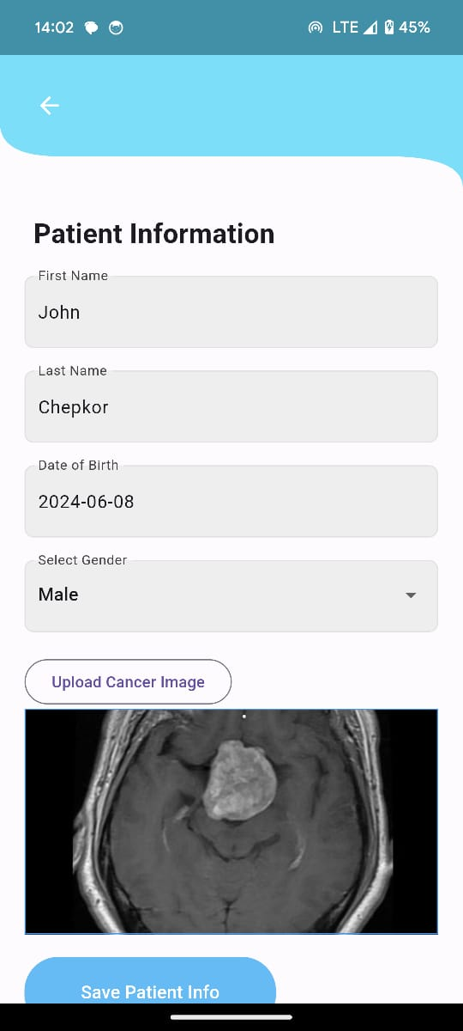

Figure 39 Patient entry data page

### 6. Viewing and Saving Diagnostic Results

* **Step 1**: After the diagnosis, view the detailed results presented on the screen, which will then be saved under patient records

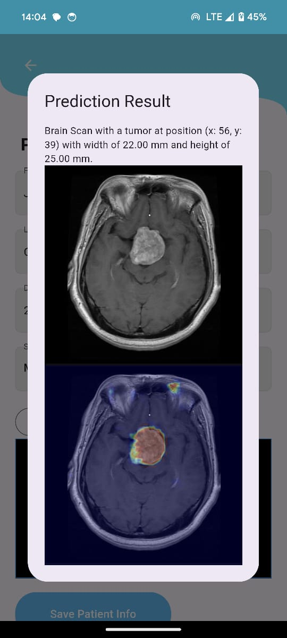

Figure 40 Diagnosis Results



Figure 41 Report

APPENDIX B: SCREENSHOT OF SOURCE CODE SNIPPETS

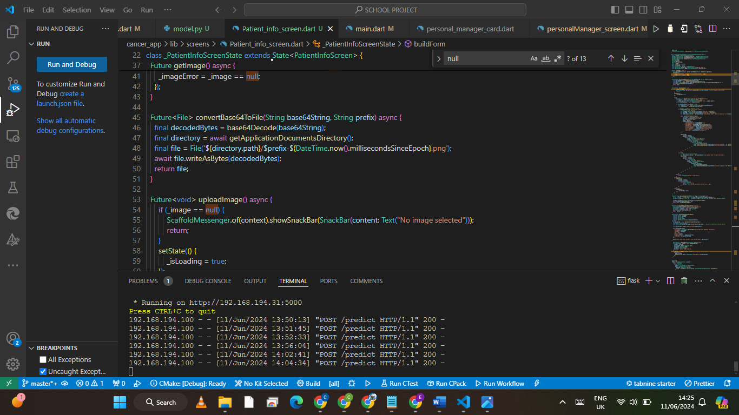

APPENDIX C: PROJECT SCHEDULE

